1. Latihan 2A

package latihan2a;

import java.awt.BorderLayout;

import java.awt.Frame;

import javax.swing.*;

public class Latihan2A extends JFrame{

JButton nButt = new JButton("NORTH");

JButton sButt = new JButton("SOUTH");

JButton eButt = new JButton("EAST");

JButton wButt = new JButton("WEST");

JButton cButt = new JButton("CENTER");

public Latihan2A(){

super("Border Layout Beraksi");

setSize(1000, 780);

setDefaultCloseOperation(JFrame.EXIT_ON_CLOSE);

setLayout(new BorderLayout());

add(nButt, BorderLayout.NORTH);

add(sButt, BorderLayout.SOUTH);

add(eButt, BorderLayout.EAST);

add(wButt, BorderLayout.WEST);

add(cButt, BorderLayout.CENTER);

}

public static void main(String[] args) {

// TODO code application logic here

Latihan2A frame = new Latihan2A();

frame.setVisible(true);

}

}

**CODING**

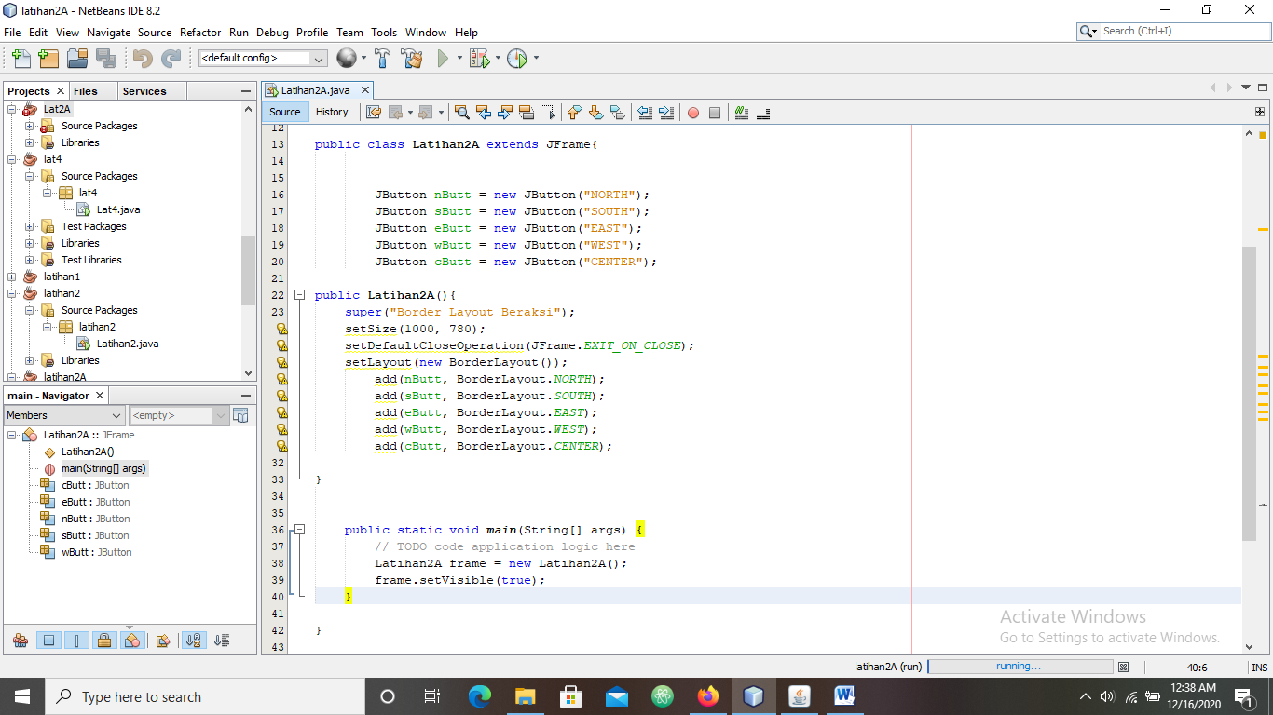

**HASIL RUN**

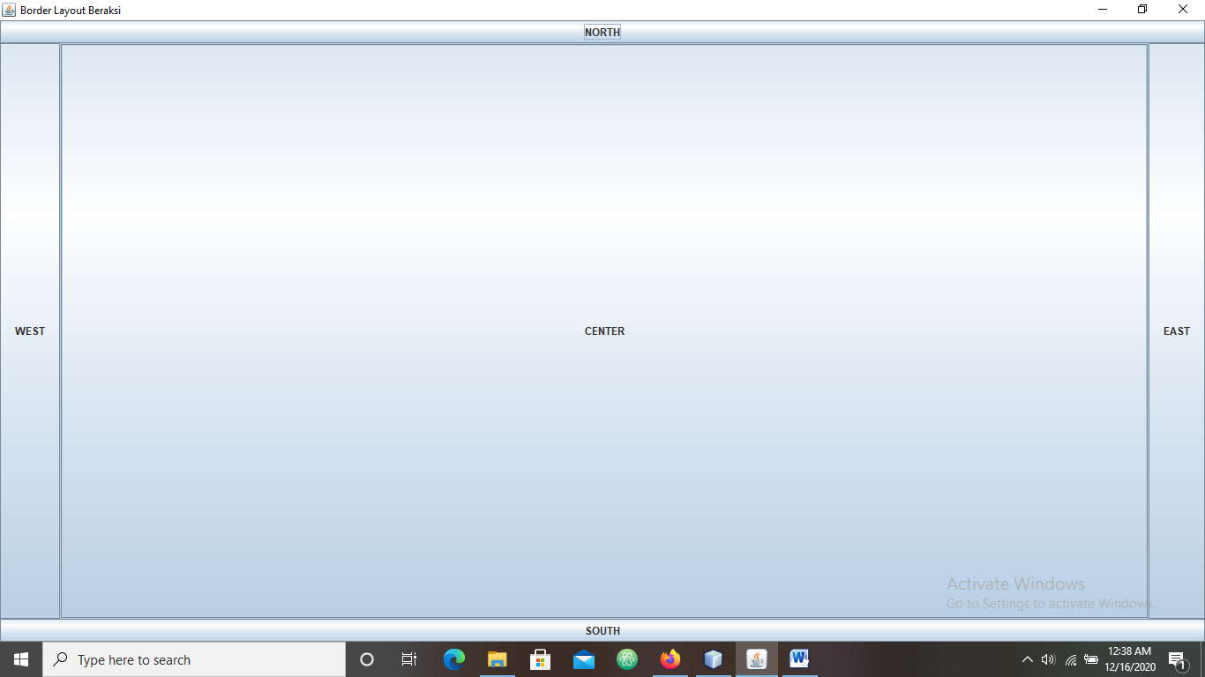

1. **LATIHAN 2B**

**package latihan2b;**

**import javax.swing.JFrame;**

**import javax.swing.JButton;**

**import java.awt.Container;**

**import java.awt.FlowLayout;**

**public class Latihan2B extends JFrame {**

**public Latihan2B(){**

**FlowLayout flowlayout = new FlowLayout(FlowLayout.CENTER, 5, 10);**

**//Memperoleh konten pane dari frame**

**Container container = getContentPane();**

**//Mengatur layout manager dari content pane**

**container.setLayout(flowlayout);**

**//Menambahkan lima button ke content pane**

**container.add(new JButton("Tombol 1"));**

**container.add(new JButton("Tombol 2"));**

**container.add(new JButton("Tombol 3"));**

**container.add(new JButton("Tombol 4"));**

**container.add(new JButton("Tombol 5"));**

**}**

**public static void main(String[] args) {**

**// TODO code application logic here**

**Latihan2B jendela = new Latihan2B();**

**jendela.setTitle("Flowlayout");**

**jendela.setDefaultCloseOperation(JFrame.EXIT_ON_CLOSE);**

**jendela.setSize(320, 120);**

**jendela.setVisible(true);**

**}**

**}**

**CODING**

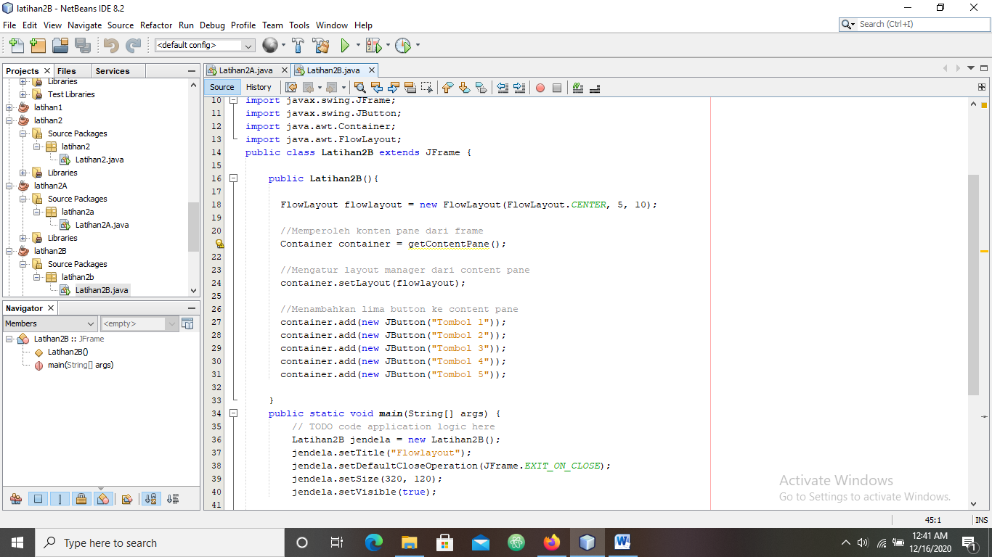

**HASIL RUN**

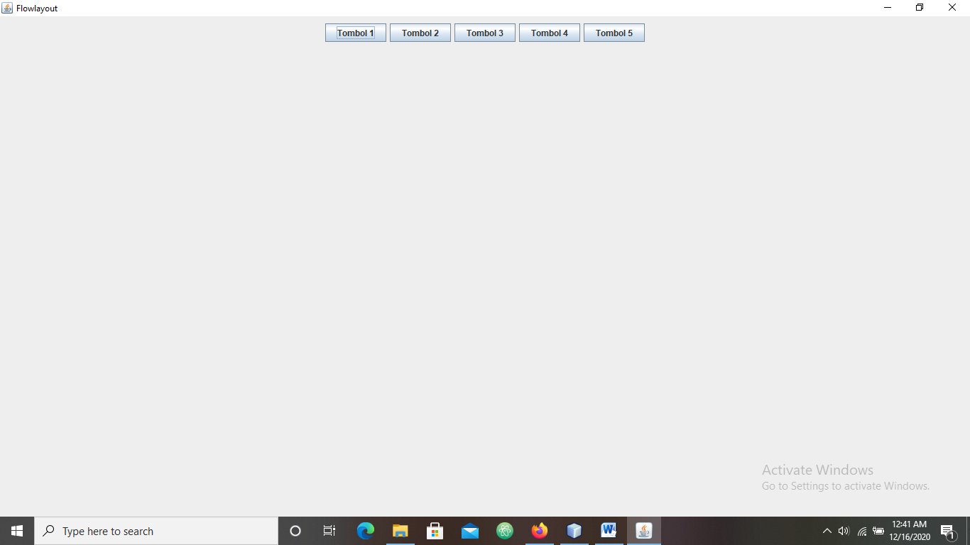

1. **LATIHAN2C**

**package latihan2c;**

**import javax.swing.JFrame;**

**import javax.swing.JButton;**

**import java.awt.Container;**

**import java.awt.FlowLayout;**

**import java.awt.GridLayout;**

**import javax.swing.JPanel;**

**public class Latihan2C extends JFrame{**

**JButton nurul = new JButton("nurul");**

**JButton fitrah = new JButton("fitrah");**

**JButton nur = new JButton("nur");**

**JButton audrey = new JButton("audrey");**

**JButton natasya = new JButton("natasya");**

**JButton maya = new JButton("maya");**

**JButton fitri = new JButton("fitri");**

**JButton puspita = new JButton("puspita");**

**JButton sari = new JButton("sari");**

**public Latihan2C() {**

**super(" Grid Layout Beraksi");**

**setSize(260, 260);**

**setDefaultCloseOperation(JFrame.EXIT_ON_CLOSE);**

**JPanel pane = new JPanel();**

**GridLayout family = new GridLayout(3, 3, 10, 10);**

**pane.setLayout(family);**

**pane.add(nurul);pane.add(fitrah);pane.add(nur);**

**pane.add(audrey);pane.add(natasya);pane.add(maya);**

**pane.add(fitri);pane.add(puspita);pane.add(sari);**

**add(pane);**

**setVisible(true);**

**}**

**public static void main(String[] args) {**

**Latihan2C frame = new Latihan2C();**

**}**

**}**

**CODING**

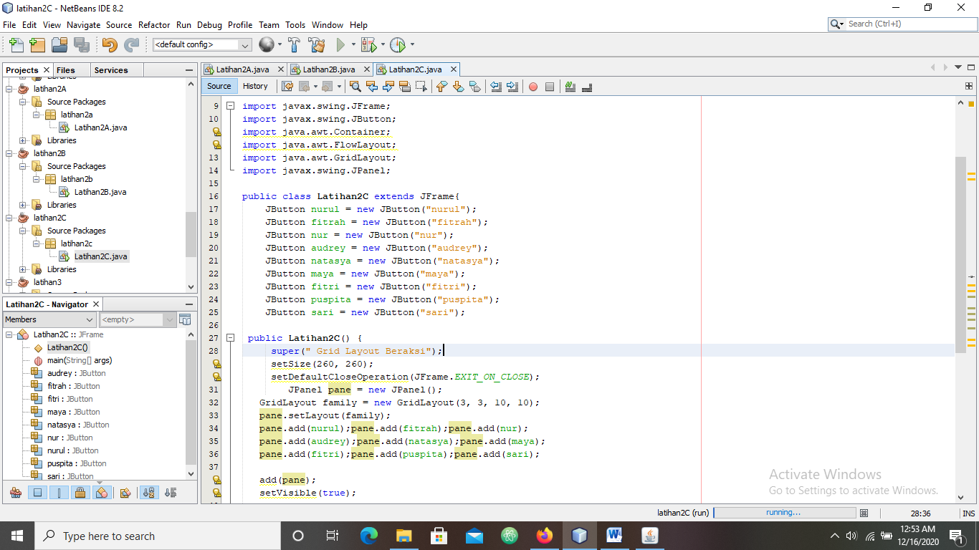

**HASIL RUN**

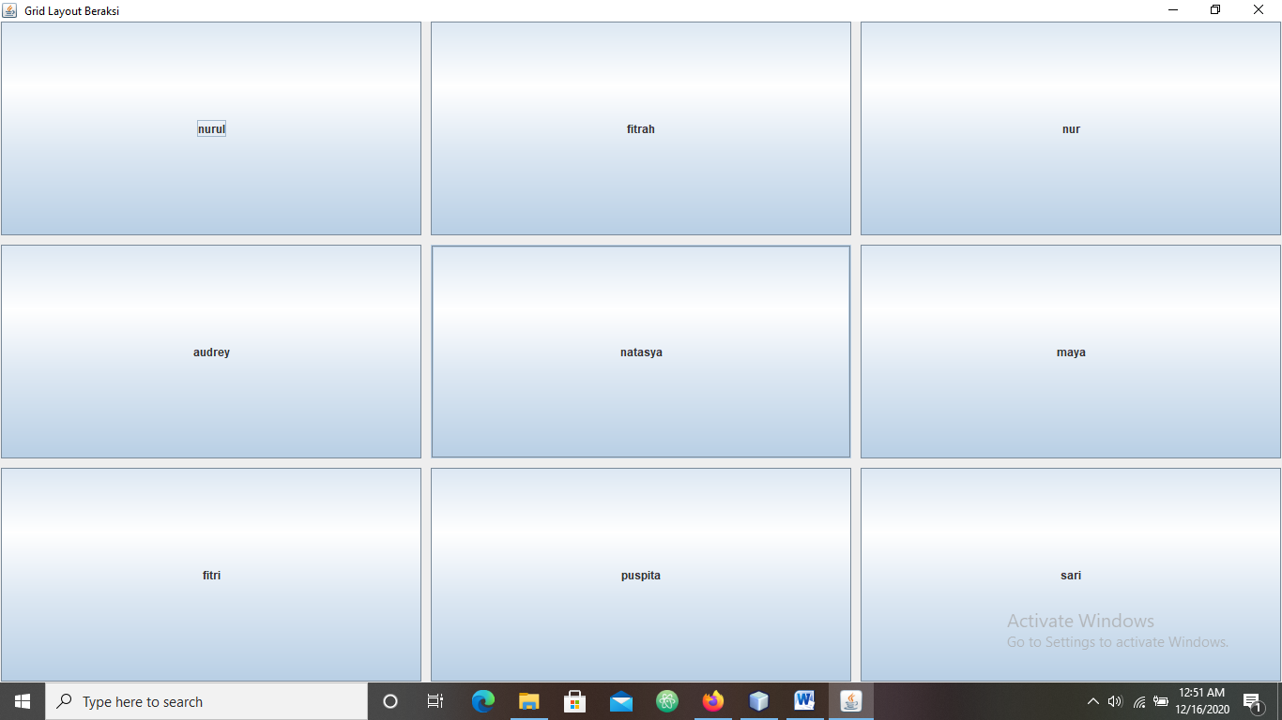

1. **LATIHAN2D**

**package latihan2d;**

**import java.awt.Button;**

**import java.awt.GridBagConstraints;**

**import java.awt.GridBagLayout;**

**import javax.swing.*;**

**public class Latihan2D extends JFrame{**

**public static void main(String[] args) {**

**Latihan2D lat2 = new Latihan2D();**

**}**

**public Latihan2D(){**

**GridBagLayout grid = new GridBagLayout();**

**GridBagConstraints gbc = new GridBagConstraints();**

**setLayout(grid);**

**setTitle("GridBag Layout Example");**

**GridBagLayout layout = new GridBagLayout();**

**this.setLayout(layout);**

**gbc.fill = GridBagConstraints.HORIZONTAL;**

**gbc.ipady = 30;**

**gbc.gridx = 0;**

**gbc.gridy = 0;**

**this.add(new Button("Button One"), gbc);**

**gbc.ipady = 30;**

**gbc.gridx = 1;**

**gbc.gridy = 0;**

**this.add(new Button("Button two"), gbc);**

**gbc.fill = GridBagConstraints.HORIZONTAL;**

**gbc.ipady = 30;**

**gbc.gridx = 2;**

**gbc.gridy = 0;**

**this.add(new Button("Button Three"), gbc);**

**gbc.ipady = 30;**

**gbc.gridx = 0;**

**gbc.gridy = 1;**

**this.add(new Button("Button Four"), gbc);**

**gbc.gridx = 1;**

**gbc.gridy = 1;**

**gbc.fill = GridBagConstraints.HORIZONTAL;**

**gbc.gridwidth = 2;**

**this.add(new Button("Button five"), gbc);**

**setSize(300, 300);**

**setPreferredSize(getSize());**

**setVisible(true);**

**setDefaultCloseOperation(EXIT_ON_CLOSE);**

**}**

**}**

**CODING**

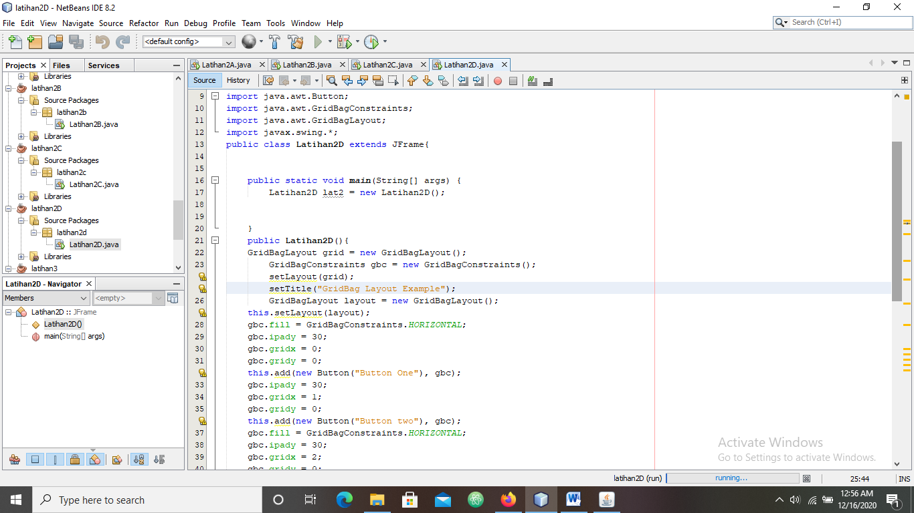

**HASIL RUN**

